OPN-2005/OPN-2006/PX-20/RS-3000

Bluetooth Application Manual

Version RFL3791H (OPN-2005) / RFM3791L (PX-20) / RFN3791L (OPN-2006) / RFZ3791L (RS-3000)

March, 2022

Opticon Sensors Europe BV

Opticon, Inc.

**Contents**

1 Overview 3

1.1 Capabilities 3

2 Configuration 4

2.1 Minimum required Operating System (OS) version 4

2.2 Software updates 4

2.3 Supported defaults 5

3 Connecting your Bluetooth companion scanner as Bluetooth keyboard (HID) 6

4 Connecting your Bluetooth companion scanner as a Virtual Com port (VCP) 9

4.1 Configuring a remote Bluetooth address 9

4.2 Connect as master 9

4.3 Connect as slave 10

5 Universal Menu Book support 13

5.1 Supported Bluetooth features 13

5.2 Apple iPhone/iPad support 14

5.3 Memorizing 14

5.4 Other Features 14

6 Other Bluetooth companion scanner applications 15

6.1 Software V3727x: OPN-2001 simulation application 15

6.2 Software V3793x: Batch application 15

Trouble shooting 16

6.3 Restart mechanisms 16

6.4 Halting your application 16

6.5 Halting the Operating System (only necessary in case a corrupt OS is installed) 16

7 Version history * 17

CAUTION: This information is subject to change without prior notice.

**Copyright 2022, Opticon Sensors Europe BV, all rights reserved.**

This manual may not, in whole or in part, be copied, photocopied, reproduced, translated or converted to any electronic or machine readable form without prior written consent of Opticon Sensors Europe.

THE GENERAL USE AND FUNCTIONING OF THE BAR CODE TERMINAL IS DESCRIBED IN THIS DOCUMENT. ALSO GENERAL SETUP INSTRUCTIONS TO GET STARTED ARE DESCRIBED IN THIS DOCUMENT. FOR FURTHER INSTRUCTIONS CONSULT OPTICON OR YOUR LOCAL DEALER.

# Overview

The OPN-2005/6, RS-3000 and PX-20 barcode terminals (referred to in this document as; ’’Bluetooth companion scanners’’) are, by default, supplied with this Bluetooth application that enables all its Bluetooth capabilities. Since the companion scanners don’t have a display to show instructions nor have a keyboard to change the settings, a user interface is implemented that consists entirely of using just the two keys and reading barcodes. This brief setup guide describes the features as well as instructions to be able to use this application.

More product details, additional support or configuration options to your own preferences (by Universal menu book) will be updated at [www.opticon.com](http://www.opticon.com) and <http://opticonfigure.opticon.com/>

Information about how to install and use a Bluetooth stack on your remote device, like a PC or mobile device, please check the manual of your Bluetooth device.

## Capabilities

The following features are currently supported:

* Connecting to a remote host device (as master) and transmitting data using a Bluetooth virtual COM port (VCP)
* Making the barcode scanner connectable and discoverable (as slave) to allow a remote host device to connect with the barcode scanner, enabling the transmission of data using a Bluetooth virtual COM port (VCP)
* Making the barcode scanner connectable and discoverable (as slave) as an HID (keyboard) device to allow the remote host device to connect, whereupon it transmit each character of barcode data as keyboard presses
* Reconnecting to a paired remote host device (as master) to quickly reestablish a lost Bluetooth HID connection without having to redo the pairing.
* Secure Simple Pairing, which allows the Bluetooth companion scanner to pair with a remote host device without the user having to enter a PIN code
* Opticon Universal menu book support to configure barcode decoders, prefixes and suffixes, read modes, buzzer/LED settings, Bluetooth configurations, and switching between HID or VCP as the Bluetooth interface
* Use of the trigger and clear key to quickly (re)connect, disconnect and make discoverable
* Storing of settings in non-volatile memory to allow all settings to be restored after a reset
* Configuration of the application by using Opticon serial commands
* Easy software upgrading by USB-VCP using Appload.
* iPhone / iPad compatibility
* USB-VCP and USB-HID support when not connected to Bluetooth
* Low battery warning and battery check

# **Configuration**

## Minimum required Operating System (OS) version

This Bluetooth application requires the following minimal OS version:

* OPN-2005: RBLV0038
* OPN-2006: RBNV0047 *(and Boot loader RANV0016)*
* PX-20: RBMV0047 *(and Boot loader RAMV0016)*
* RS-3000: RBZV0047 *(and Boot loader RAMV0016)*

If you want to check the currently installed OS and application version it is possible to transmit both versions by USB-VCP by reading the 'Z1' menu label (See Universal menu book chapter 7 or <http://opticonfigure.opticon.com/> (Miscellaneous > Diagnostics)

It's also possible to use Appload (Utilities > Show software version) to check the OS version.

## Software updates

In the future more features and bug fixes are likely to be implemented into the OS and this application. To find out if there are software updates available, please check our website. All available software and documentation can be found under:

'Service and support > 'Downloads' > OPN-2005/ OPN-2006 / PX-20 / RS-3000 at [www.opticon.com](http://www.opticon.com).

## Supported defaults

The following default settings are supported.

(*The labels below can be read without reading any SET/END labels)*

|  |  |  |
| --- | --- | --- |
| Bluetooth HID *  *(default)* |  |  |
| Bluetooth VCP * |  |  |

*\* If you only have an Opticon Universal menu book available which doesn't list 'C02' or 'C05' as supported defaults, it's possible to use RS232 ('U2') or Bluetooth ('SO') instead of 'C05'.*

All listed defaults are also available at <http://opticonfigure.opticon.com/> (Defaults)

In case it’s required to (also) be able to transmit any scanned barcodes using USB-VCP (COM port) or USB-HID (keyboard), then it’s possible to do this by reading one of the labels below.

|  |  |  |
| --- | --- | --- |
| USB-VCP  *(+ Bluetooth VCP)* |  |  |
| USB-HID  (+ Bluetooth HID) |  |  |

*Notes:*

* *When using USB-HID it’s not directly possible to load software using Appload. To be able to load software, switch back to Bluetooth-VCP or USB-VCP default.*
* *Transmission by USB only works while not being connected to Bluetooth*
* From application version RFL3791F it is also possible to configure the Bluetooth name of the device.

|  |  |
| --- | --- |
| **Set Bluetooth Local Name** OPN2006_yyyy where yyyy is the last four digits of the Bluetooth address ( **default** ) |  |
| **Set Bluetooth Local Name** OPN2006_xxxxxx where xxxxxx is the serial number. |  |

# Connecting your Bluetooth companion scanner as Bluetooth keyboard (HID)

The first step of connecting your device as Bluetooth keyboard to a remote host device is to make sure the Bluetooth HID default is configured (see 'Supported defaults').

When using Bluetooth HID, the remote host device always has to make the first connection attempt. Therefore it is not necessary to configure the remote Bluetooth address, but you will have to make your barcode scanner discoverable and connectable to allow the remote device to find, pair, and connect to your device.

To make your device discoverable and connectable keep the clear key pressed for 5 seconds till the blue LED starts blinking. When this is done, let your remote device discover all Bluetooth devices in range to find your barcode device. The Bluetooth companion scanner will remain in this state for 2 minutes.

*Screenshot of a PX-20 that has been discovered on a remote host PC.*

After you've discovered your device you can tell your remote host device to connect with it.

Depending on your Operating System, Bluetooth stack, and supported Bluetooth version, you will either be asked to enter a PIN code on your remote host device, you will be shown a random PIN code to enter with the barcode device or you won’t be prompted for a PIN code at all.

If you are allowed to enter any PIN code, then it is easiest to choose the last 4 digits of the Bluetooth address of your device as the PIN code, since that is already set as the default PIN code. Scan the 'Fixed PIN code' label below to configure this. To change this configuration back to default again (i.e. entering the PIN code manually) you can read the other label.

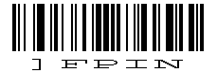

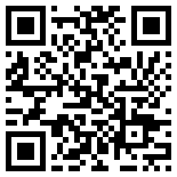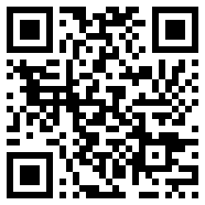

***Use fixed PIN code******Enter PIN code******manual***

***(using numeric direct input labels)***

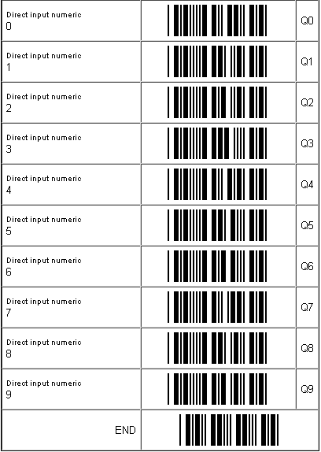If you want to use a different PIN code, or if you are only allowed to enter a random PIN code on your device, then you will have to enter this PIN code using direct input labels below. These labels can be found in the Universal Menu Book as well. After scanning each number of the PIN code, scan the END label to send the PIN code to the remote device.

When executed correctly your device should now be connected and you should be allowed to scan and transmit barcodes into any document or application that accepts keyboard input. If the remote device does establish the pairing, but doesn't automatically connect, you might have to manually connect afterwards by pressing the trigger key for 5 seconds.

To manually end a connection you can press the clear key for 5 seconds to disconnect your device.

If you've lost your connection, then your device will try to reconnect automatically for about 1 minute, but if that fails you can reconnect manually by pressing the trigger key for 5 seconds. The trigger key allows you to reconnect without having to enter the PIN code again as long as the remote device doesn't lose the pairing information and the Bluetooth companion scanner wasn't reset to default (or the remote Bluetooth address wasn’t changed).

If the pair was ever lost or you want to connect to another remote device you will have use the clear key again to make your device connectable and allow the remote device to connect and pair with it.

# Connecting your Bluetooth companion scanner as a Virtual Com port (VCP)

The first step of connecting your device as a Bluetooth Virtual Com Port to a remote host device is to make sure that Bluetooth VCP default is configured (see 'Supported defaults').

When using Bluetooth VCP, the remote host device can either connect to your Bluetooth companion scanner (slave mode) or your Bluetooth companion scanner can connect to the remote device (master).

## Configuring a remote Bluetooth address

If you want your device to connect to a remote host device (as master) it will be necessary to configure the Bluetooth address of the remote host device first.

Usually the address is displayed on the product label as a hexadecimal code (example: 00-11-F6-03-39-69). Otherwise consult the documentation of the device to learn how to retrieve the Bluetooth address. To configure this Bluetooth address in the Bluetooth companion scanner you'll have to create a barcode label containing this hexadecimal code as described below.

Opticon provides a simple online application for this purpose:

http://opticonfigure.opticon.com/bluetooth.asp

1. Type in the digits of the hexadecimal code in numbers and capital characters without dashes, dots, and spaces (example: 0011F6033969).
2. Submit the code into a barcode and print the screen to have it available for scanning.

After you've created the barcode, you can scan the barcode to configure the Bluetooth address and save it in non-volatile memory. (The bluetooth companion scanner will automatically try to establish a Bluetooth connection when reading this label).

## Connect as master

Depending on the Operating System and Bluetooth stack of your desktop computer, laptop, or mobile Bluetooth device, it is necessary to first open the (incoming) Bluetooth Virtual COM port, before you will be able to connect your Bluetooth companion scanner as a master to your remote host device. Using applications like Hyperterminal or the RS232 monitor of Appload, it is possible to open the Bluetooth Virtual Com Port prior to the connection attempt. For more information on how to open a COM port, please refer to documentation of your remote host device.

The first time you try to connect your Bluetooth companion scanner to a Bluetooth device you will have to scan the Bluetooth address label created and described in the prior section. After that, it will also be possible to repeat a connection attempt by holding the trigger key for 5 seconds (until the blue LED starts blinking). It should be noted too that if you first connect with the Bluetooth companion scanner functioning as a slave device, any subsequent connections can be formed by holding the trigger key for 5 seconds.

If you haven't disabled authentication on your remote host device, and your remote host device doesn't use Bluetooth 2.1+, then you will be requested to enter a PIN code (or passkey) during pairing. The default PIN code of the Bluetooth companion scanner equals the last 4 digits of the Bluetooth address. These last 4 digits of the Bluetooth address are also shown in the Bluetooth name. If you wish to use a different PIN code, then this is possible by using the 'Set/end PIN-code label' menu options, which can be found in chapter 2.3.2 of the Universal Menu Book or at<http://opticonfigure.opticon.com/> (Interface > Bluetooth options > Security)

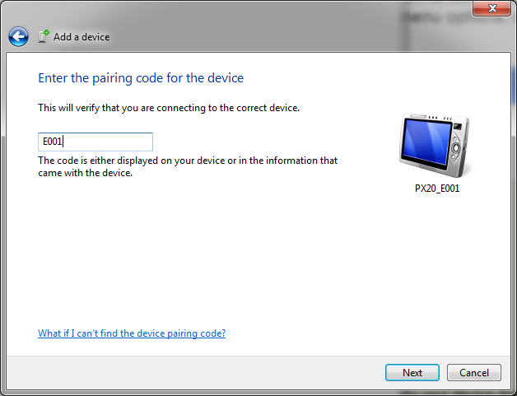

Example of a request on a Windows device to enter a passkey (a.k.a. PIN-code)

When executed correctly your device should now be connected as Virtual Com port to your remote device and you should be able to scan and transmit barcodes as serial data.

If you've lost your connection or closed the Virtual Com port, then the Bluetooth companion scanner will try to reconnect for about 1 minute. After that you can reconnect manually by pressing the trigger key for 5 seconds. To change this auto reconnect time, use the menu options found in chapter '2.3.6 Auto reconnect options' of the Universal menu book or at<http://opticonfigure.opticon.com/> (Interface > Bluetooth options > Auto reconnect options’).

To manually end your connection you can press the clear key for 5 seconds to disconnect.

## Connect as slave

When you want a remote Bluetooth device to connect with your Bluetooth companion scanner, then it’s not necessary to configure the remote Bluetooth address, but you will have to make your device discoverable and connectable to allow the remote device to find and connect to your Bluetooth companion scanner.

To make your Bluetooth companion scanner discoverable and connectable for 2 minutes, keep the clear key pressed for 5 seconds until the blue LED starts blinking. After that you should let your remote device discover all Bluetooth devices in range to find your bar code device.

Screen shot of a discovered PX-20.

After you've successfully discovered your Bluetooth companion scanner you can pair it with your remote host device.

If you haven't disabled authentication on your remote device, or your remote host device doesn’t support Bluetooth 2.1+, then you will be requested to enter a PIN code (or passkey) on your remote device. The default PIN code of the Bluetooth companion scanner equals the last 4 digits of the Bluetooth address. These last 4 digits of the Bluetooth address are also shown in the Bluetooth local name. If you wish to use a different PIN code, then this is possible by using the 'Set/End PIN-code label' menu options, which can be found in chapter 2.3.2 of the Universal Menu Book or at<http://opticonfigure.opticon.com/> (Interface > Bluetooth options > Security). Use the direct input barcodes listed earlier in this manual to specify the PIN-code.

.

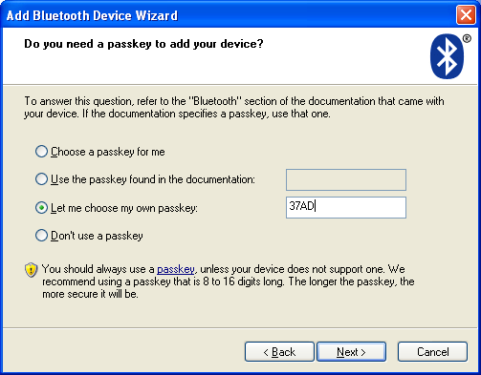Screenshot of entering a passkey (a.k.a. PIN-code) on a Windows device

If successful, the Bluetooth companion scanner should now be successfully paired with your remote Bluetooth device and the Virtual Com port will be ready to be used.

To be able to scan and transmit barcodes as serial data, open the Bluetooth Virtual Com port on your remote device to establish the connection with your device. You can open this Bluetooth Virtual Com port with an application such as HyperTerminal or Appload’s RS232 Monitor.

If you've lost your connection or closed the Virtual Com port, then the Bluetooth companion scanner will stay connectable for about 2 minutes*. This will allow you to open the Virtual Com port on the remote host device to reconnect. After those 2 minutes, use the small key to make the Bluetooth companion scanner connectable again. Also open the Virtual Com port on the remote host device to allow the remote host device to re-establish the connection.

To manually end your connection, press the clear key for 5 seconds to disconnect your barcode device.

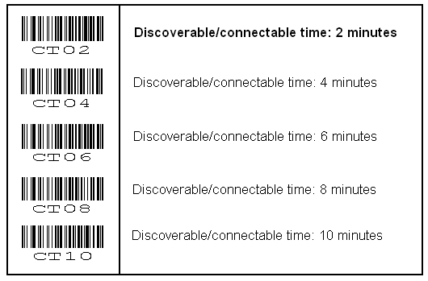

*\* The labels below allow you to change the time that the device will stay connectable*

# Universal Menu Book support

The Bluetooth companion scanner support the reading of various configuration options that can be found in the Universal Menu Book. This makes it possible to customize the behaviour of the embedded application without having to actually change the source code of the application.

The Bluetooth companion scanner support the menu options listed in the following chapters:

* 1. Defaults (See chapter 'Supported defaults' at the start of this set-up guide)
* 2.3. Bluetooth options (See 'Supported Bluetooth features' below)
* 3.1 Enabling/disabling readable codes
* 3.2 Setting of fixed, minimum and maximum lengths
* 3.3 Code specific options (almost all options are supported except some 2D decoder options)
* 4.1 Case conversion
* 4.2 Set prefixes
* 4.3 Set suffixes
* 5.1 Read modes, add-on wait modes
* 5.1.1 Multiple read reset time
* 5.1.2 Quite zone options (margins)
* 5.2. Read time options
* 5.4 Redundancy
* 5.5 Positive and negative barcodes
* 6.1 Buzzer settings
* 6.2 Good read LED
* 7.1 Diagnostics
* 7.2 Enabling / disabling configuring via serial commands

All listed options are also available at <http://opticonfigure.opticon.com/>

## Supported Bluetooth features

In the Opticon Universal Menu Book there are additional Bluetooth features listed for Opticon barcode readers with Bluetooth support. Some of these features are also available in this application.

The following of these listed features are supported:

* Chapter 2.3.1: Bluetooth connection labels
* +-CONN-+ (Manually connect label)
* +-DISC-+ (Manually disconnect label)
* +-DSCO-+ (Make discoverable / connectable)
* Chapter 2.3.2: Bluetooth security (Authentication / encryption)
* Chapter 2.3.3: Configurable Trigger-to-connect time (default = 3 seconds)
* Chapter 2.3.4: Configurable Trigger-to-disconnect time (default = 5 seconds)
* Chapter 2.3.6: Auto reconnect options (default = 1 minute)
* Chapter 2.3.7: Wireless power saving options
* Chapter 2.3.8: Memorizing

See also<http://opticonfigure.opticon.com/> (Interface > Bluetooth options)

## Apple iPhone/iPad support

When iPhone/iPad mode is enabled it’s possible to toggle the iOS onscreen keyboard and use the trigger key to wake up the iPhone/iPad from standby. It is recommended to disable the passcode lock option to prevent barcodes from being entered as a passcode when waking up from standby.

_+-IOSON-+_

*Enable iPhone/iPad mode*

_+-IOSOFF-+_

*Disable iPhone/iPad mode*

Read one of the labels above to enable/disable iOS compatibility.

## Memorizing

This application supports memorizing of barcodes in case the Bluetooth companion scanner loses its connection with a remote Bluetooth device. This will allow barcodes scanned to be saved in in memory and be transmitted when a connection is re-established.

See Section 2.3.8 of the Universal Menu Book or go to <http://opticonfigure.opticon.com/> (Interface > Bluetooth options > Memorizing) for all available options

## Other Features

The Bluetooth companion scanner will show a yellow/orange LED 10 times for 1 minute when the battery is too low for normal operation. After this, the device will shut off automatically. If this indicator is seen, it is imperative that the device be attached to USB to charge the battery.

The current battery percentage level can be checked by sending the following serially:

<ESC>]BATT<CR>

When the device is in Bluetooth VCP or USB-VCP mode. In HID mode, the following codes can be scanned:

_ZZ_

_BATT_

_ZZ_

# Other Bluetooth companion scanner applications

Besides this Bluetooth application there are 3 other applications available on our website that might fit your specific use case better.

## Software V3727x: OPN-2001 simulation application

This application turns the Bluetooth companion scanner into an OPN-2001 compatible batch scanner.

Besides USB, any stored barcode data can also be retrieved from the barcode scanner by using Bluetooth.

Use this application in combination with the OPN-2001 application for Windows (or develop your own application using the SDK that's available for the OPN-2001).

Note: When planning to use the OPN-2005/6 solely as a standard OPN-2001, without Bluetooth or the need to run other applications, please note the following (hardware) differences:

1. The OPN-2005/6 does not support laser aiming (laser dot)
2. The OPN-2005/6 cannot change its scan angle to shorten the laser line
3. Not all supported 2D symbologies of the PX-20 and the RS-3000 can be configured using the OPN-2001 application. Use the Universal menu book or <http://opticonfigure.opticon.com/> instead.

## Software V3793x: Batch application

This software turns the Bluetooth companion scanner into a batch scanner that can transmit its saved data as a file. Use this application in combination with the OseComm or NetO32 Windows application.

This embedded application also makes it possible to use the Bluetooth companion scanner as USB Mass Storage device, which stores all bar codes in a file that can be retrieved with any file explorer on any platform supporting USB Mass Storage.

The output format of the barcode file (comma separated) can be configured using the setup chart that can be found in the included user guide.

# Trouble shooting

Since the Bluetooth companion scanner don’t have displays, they also don't have a system menu to resort to when a crashing application or OS prevents you from loading new software on the Bluetooth companion scanner.  
  
For this reason the Bluetooth companion scanner have a few escape mechanisms to allow you to restart, halt your application, and/or install new software. This can be very useful in case the Bluetooth companion scanner has crashed or is constantly restarting due to a crashing application.

## Restart mechanisms

|  |  |
| --- | --- |
| **Automatic** | The Bluetooth companion scanner have watchdog timers to determine whether the OS is still running or has crashed. The watchdog timer will cause the device to restart after 3 seconds if the OS has crashed. This watchdog timer will not cause a restart when only the application has crashed. |
| **Manually** | The Bluetooth companion scanner have a manual restart mechanism that allows you to restart in situations that the OS is still running, but the application has crashed. In order to activate this mechanism, press and hold both the trigger and delete key for at least 20 seconds. After the Bluetooth companion scanner has sounded a short beep, you can release both keys to complete the restart. |

## Halting your application

* Restart your application using one of the two restart methods listed above, but keep both keys pressed after the short beep.
* Release the trigger key first to halt the application.

*If successful, the LED of your Bluetooth companion scanner* *should now be blinking yellow/orange. You should now be able to load new application or OS software.*

*To exit the halted application state, press both keys for 20 seconds*

## Halting the Operating System (only necessary in case a corrupt OS is installed)

* Restart your application using one of the 2 methods listed above, but keep both keys pressed after the short beep.
* Release the clear key first to halt the Operating system.

*If successful, the LED of your Bluetooth companion scanner* *should now be blinking red. You should now be able to load a new OS.*

*To exit the halted Operating System state, press both keys for 3 seconds*

# Version history *

|  |  |  |
| --- | --- | --- |
| RFL37910  (OS: RBLV0012) | First release for OPN200 | March 21, 2013 |
| RFL37911  (OS: RBxV0016) | Added support for PX-20 | April 16, 2013 |
| RFL37912 | Merged Advanced Bluetooth Demo features into this application  Fixed iOS toggle  Fixed reconnect failure | May 28, 2013 |
| RFL37913 | Changed LED indicators during connecting/disconnecting to make it more clear when the OS was busy. | June 12, 2013 |
| RFL37914 | Address an issue where the scan laser would not come on when connecting to certain iOS devices  Add support for a low battery indicator and the ]BATT command, to check the current battery percentage level | July 5, 2013 |
| RFL37915  (OS: RBxV0019) | Added battery status options | July 19, 2013 |
| RFL37916  (OS: RBxV0021) | Changes factory default to Bluetooth-HID | August 5, 2013 |
| RFL37917 | Added support for OS control of Bluetooth PIN type (fixed and manual/variable) | August 7, 2013 |
| RFx37918 /  RFM37918  (OS: RBxV0025) | Fixed Bluetooth reconnect issues  Fixed USB-VCP issues  Improved scan behavior of PX-20  Lowered power consumption of OPN-2005  Fixed USB-MSD issues (use batch application) | January 24, 2014 |
| RFx37919  (OS: RBxV0026) | Fixed Bluetooth-VCP master connect issue | February 7, 2014 |
| RFL3791A /  RFM3791A  (OS: RBxV0030) | Updated manual for OPN-2006  Improved battery life  Improved USB/Bluetooth transmission speed  Added UTF-8 support in 2D barcodes | Sept 15, 2014 |
| RFL3791C /  RFM3791C /  RFN3791C  (OS: RBxV0035) | Added Bluetooth Low Energy (BLE) support (OPN-2006 and PX-20 only)  Separate release for OPN-2006 (RFN3791x) due to BLE Added support for OPN-2006  Added inter-character-delay menu-option support  Added 1-character menu-option support  Added buzzer menu-options support  Explicitly disabled USB-MSD default (C04)  Added Battery status reports (for BLE only)  Added length menu-options for PX-20  Extended Bluetooth compatibility with more devices  Added Bluetooth LV00 to LV07 power level menu-options (OPN-2006, PX-20 and RS-3000 only) | January 28, 2016 |
| RFx3791D  (OS: RBxV0035) | Fixed memorizing issue (barcodes not transmitted)  Added memorizing option: Transmit, but don’t delete  (+-XMTO-+) | February 18, 2016 |
| RFx3791F | Fix: Auto disconnect options "AD00" .. "AD06" ( needs OS version 0036 to work ) Added menu-option: Button to Send (EBC) changed manual: orange LED to orange/yellow LED, because OPN-2006/PX-20 is actually yellow Added support of 6-digit Bluetooth address labels to connect to a OPA-xxxx | June 3, 2016 |
| RFx3791H  (OS: RBxV0037) | Added +-BTLNA-+ and +-BTLNS-+ options to set Bluetooth local name format. | November 4, 2016 |
| RFx3791J  (OS: RBxV0038) | Enabled BLE for PX-20 | December 23, 2016 |
| RFx3791K  (OS: RBxV0040) | Added: Buzzer before/after transmit ( "VZ", "VY")  Fix: +-BTLNS-+ for PX-20 and OPN-2005 | May 27, 2019 |
| RFx3791L  (OS: RBxV0047) | PX-20: Added "stand detection" options *4 / *5 (only when USB is connected)  Added RS-3000 support (RFZ3791x) | Nov 23, 2021 |
| Updated styling of the manual | March 29, 2022 |

* Bug fixes and added features in the Operating Systems of the Bluetooth companion scanners are not always listed in the application version history above.

*Please check our web site at* [*www.opticon.com*](http://www.opticon.com) *to see if there are updates available for the Operating System, this application and this manual.*